January-February 2013 Newsletter

Scotland V Italy
6 Nations Match

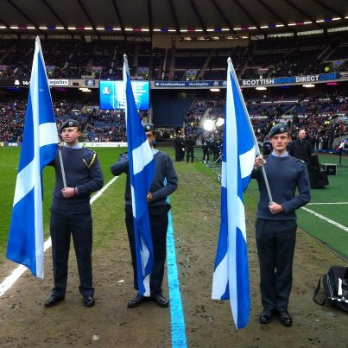

On Saturday the 9th of February, 7 cadets from 870(Dreghorn) SQN were given the chance to help with the pre-match entertainment at the Scotland v Italy 6 Nations match at Murrayfield Stadium, Edinburgh.

Most of the cadets helping, including myself, were given the task of holding the large Scotland flag behind the teams during the national anthems. The other cadets were given the task of holding smaller Scotland flags lining the tunnel which the players and Princess Anne would pass through.

It was an amazing experiencing the atmosphere in the stadium before the game and it almost made up for the cold. It also put into perspective how big the players are.
Scotland has finally won a game! I think we all enjoyed the day!

Cdt Philip

Netball Competition

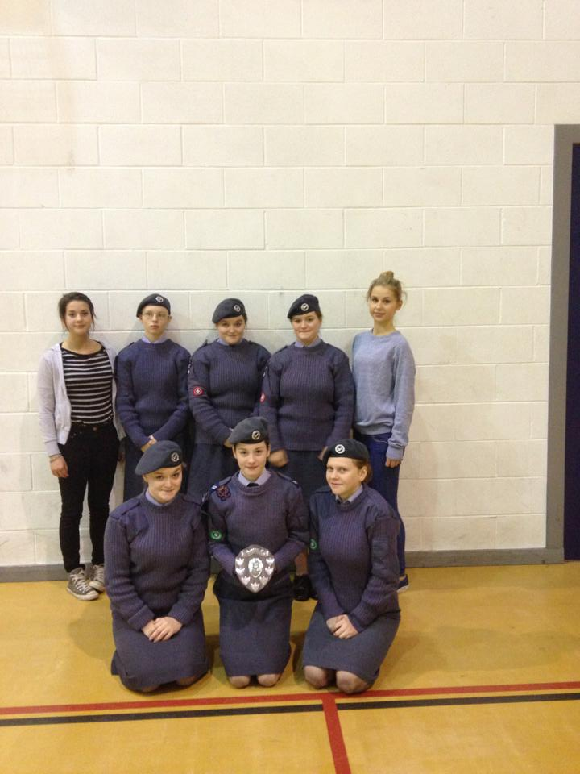
On Sunday the 3rd of February I was part of 870’s team for the girl’s netball competition. We came 4th but because the team that was 3rd and 2nd were composite teams, we were awarded the 2nd place trophy. We all enjoyed playing netball together and we all played really well. One of the games we enjoyed the most was the very last one because we were all working together really well. Cdt Z Spence, A Spence and Duncan-Lloyd were all picked for the wing team.

Cdt Spence

Music Weekend

On the weekend of the 25th to the 27thof Feb, I took part in a music development course with north region ATC music services. During the weekend we took part in an introduction to conducting course as well as a basic drumming course. Throughout the weekend we were also taught the opportunities for ATC bands and how to get things going. I chose to go on the band masters course because I am hoping to create a music service within South East Scotland Wing as there is so much potential. Thanks to this course I know now what I can achieve with ACO music and how to achieve it!

FS Birss

L98 A2 training weekend

On the 2nd to the 3rd of February I attended the L98 A2 rifle training.

Upon arriving at the Squadron at 08:45 on Saturday I was keen to see that the first thing we would be doing was diving straight into the rifle. However after having a contest to see who was able to strap up the L98, I soon found out that it was likely to be a long weekend. Throughout the day we were given short drills (NSPs) in how to handle the weapon. Upon the second day and after having a few hours to train we one by one to proceed with the test. Overall I can say that I have thoroughly enjoyed myself, it was completely worth giving up my weekend for.

Cdt Johnson

No.8 Shooting

On Thursday 10th January, 6 cadets went on to the range at our squadron and fired the no.8 rifle. I was one of the first firers. My first 5 rounds were not particularly good, there were not many even on the target!
My next 5 rounds were much better, apart from the fact I had a misfired round. My final 5 rounds were all on target.

Cpl Gardner

Silver DofE Award

Congratulations to Cpl Gardner who completed his silver DofE award in February.
I would also like to congratulate Cpl Gardner

New members

Anyone interested in joining 870 as a cadet, or member of staff, should contact the Squadron on 0131 441 3121, 870@aircadets.org, or why not come along to our parade nights on Tuesday and Thursday evenings from 19:30 – 21:30.

www.870squadron.weebly.com

Easy Fundraising

1) Go to: www.easyfundraising.org.uk
2) Register with: 870 (Dreghorn) Squadron Air Training Corps
3) Use the site to buy things you need and the squadron will earn money (It won’t cost you any extra money).

Future events

Sat 9th Mar- Rugby 6 nations

Sat 16th-Sun 17th Mar-L98a2 training

Sun 24th Mar- Wing rugby competition

Sat 6th Apr- Walk in the Pentlands

Sat 7th Apr- Water of Leith conservation tasks

Sat 13th –Sun 14th Apr–Bronze DofE practice
Expedition

Sun 14th Apr-Wing first aid competition \

Sun 28th Apr- Wing athletics competition

Sat 4th – Sun 5th May – Bronze DofE qualifying expedition

Sat 22nd – Sat 29th Jun- Summer camp at Linton-on-ouse

