June - July Newsletter 2012

Normandy Trip

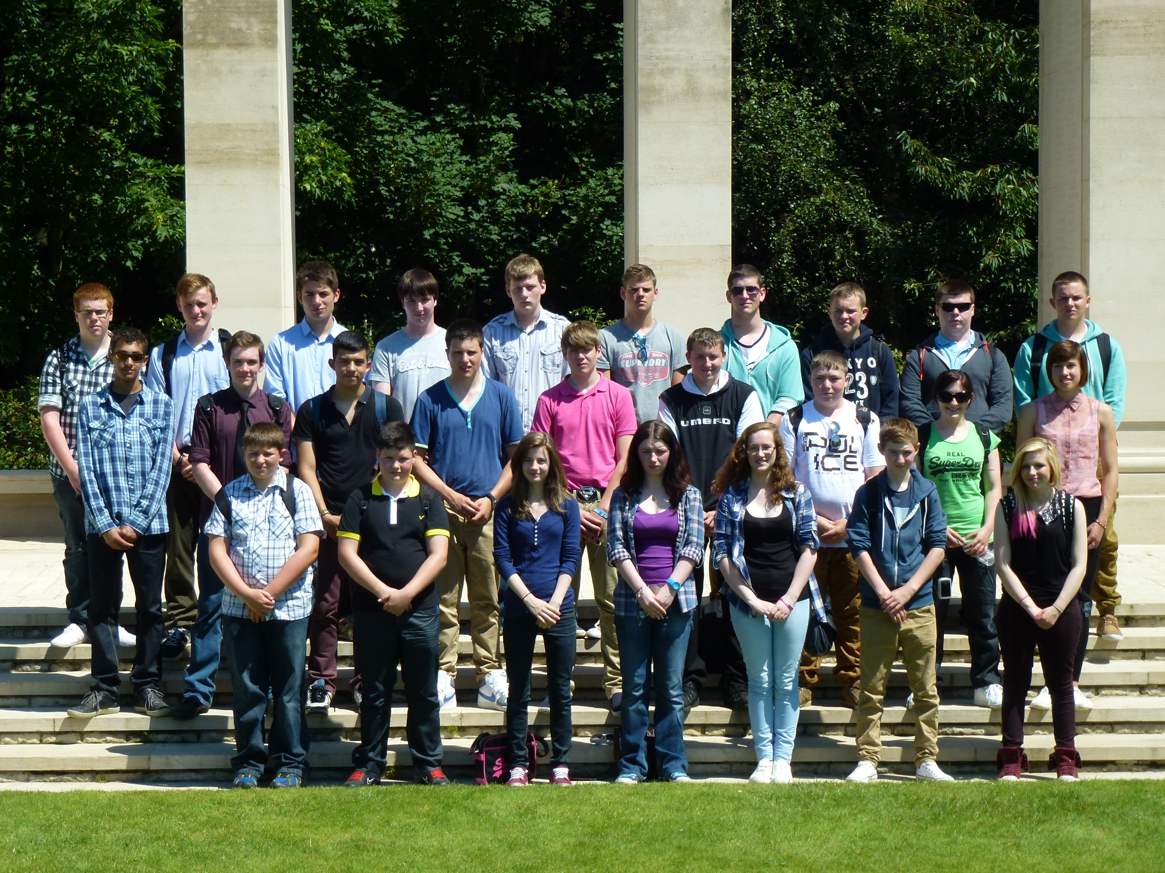
Cadets and staff from South East Scotland
Wing had a weeklong trip away to Normandy, France. The purpose of the trip was to learn about D-Day, When allied forces landed in France.

We left for Normandy at roughly half past 8 at night, to arrive at the ferry for early hours in the morning. The journey then continued for another 5/6 hours. Which we then finally reached our destination, the Chateau De Terte, run by PGL.

During our time in Normandy we visited various museums, memorials and cemeteries. Where we were trying to get all the knowledge possible and a sense of how gruesome the battles across the beaches were. What truly does put it into perspective is when you go to the American cemetery in Normandy and you see how young some of them were. Ages like just 19 years old, some of the soldiers couldn’t even be identified and so the graves are unnamed.

In the coming weeks there shall be a report about the Normandy trip with all the information about different aspects of D-Day such as the Pegasus Bridge and Mulberry harbor.

Royal salute at Edinburgh castle

On Saturday the 2nd of June; Cpl Davidson, FS Marks, Cpl Dickson, Cdt Johnson and myself attended the twenty one gun salute at Edinburgh castle provided by 105 Regiment Royal Artillery (Reserve). We arrived at the castle on a cloudy, yet dry, Scottish morning to experience what would be a once in a lifetime opportunity to celebrate Queen Elizabeth the second’s sixty years on the throne. Cadets from our own squadron joined cadets from 279DF along with Army Cadets, Sea Cadets and even one Royal Marine’s Cadet. We were stood behind the guests with our ear defenders on in full view of the exited public. The guest of honor, The Deputy Chief Constable for Edinburgh, gave the word and at midday three 105mm artillery pieces fired seven shots each at ten second intervals amounting to a full twenty one gun salute. The guns made an amazingly loud yet satisfying thunder drowning out all sound. After this we were allowed the privilege of getting pictures with the guns and their crews. The day was over quickly and by the end the proceedings the clouds had cleared and we were left with the feeling that we had done justice to the jubilee proceedings and done our duties as cadets and experienced a truly special day.
Cpl Bennett

Scottish Robotics competition
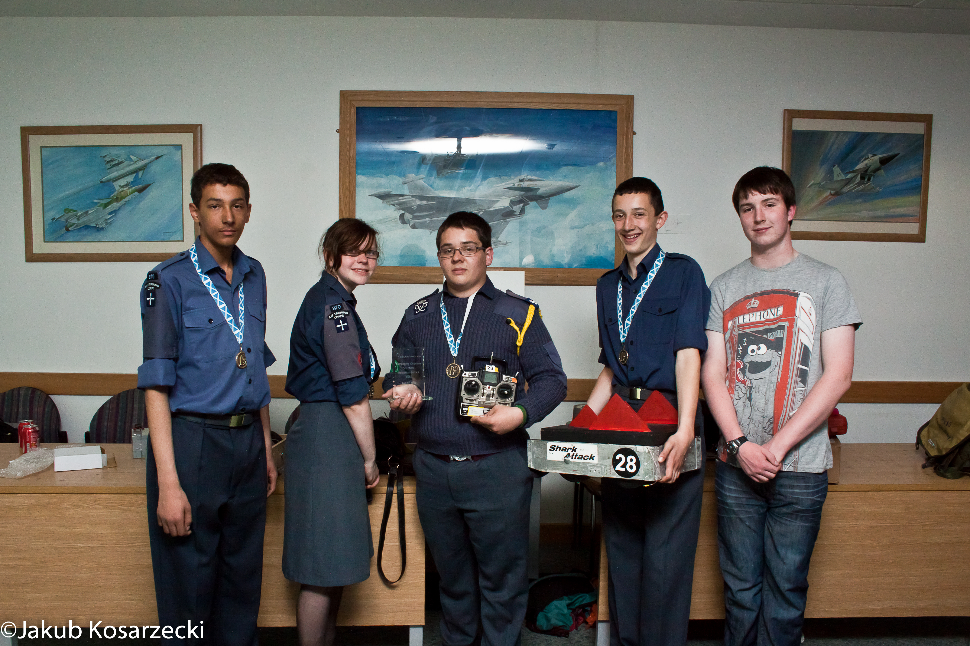
The Scottish robotics competition took place on the 9th of June, We competed with our three robots, Shark attack, doom and M.I.A. M.I.A was the newest robot which we recently built; it hadn’t even been painted! Also there was no lid. We had a lot of fun competing with other robots. We came first for the tug of war due to our robot, shark attack being a four wheel drive robot which is uncommon at the Selex Galileo (where the competition took place). We got a tour of the building; it was very large and full of very expensive equipment such as liquid nitrogen tanks. Shark attack “melted” at the end of the competition; the motor started smoking and was useless from then on. Overall I had a great time.

L98A2 Shoot

On Sunday the 24th of June, our squadron amongst others had an L98 A2 Shoot up at RAF Leuchars Range. We experienced light, to medium rain but we were sitting on the busses so it wasn’t like we were all getting soaked! Throughout the day we had a go at shooting; aiming to achieve our corps marksman badge. Many had achieved this, however I was yet to achieve over 100 points.
On my first shoot I managed to achieve a score in the mid 90’s and so this allowed me to have a second attempt, during this attempt I tied joint highest scores with Cpl Kos, which was 114 out of 120! The day was good fun as I haven’t shot the A2 in a very long time. Many in our squadron did achieve corps with the exception of a few who will get to have another go on a later occasion.

New members

Anyone interested in joining 870 as a cadet, or member of staff, should contact the Sqn on 0131 441 3121, 870@aircadets.org, or why not come along to our parade nights on Tue and Thurs evenings from 19:30 – 21:30.

